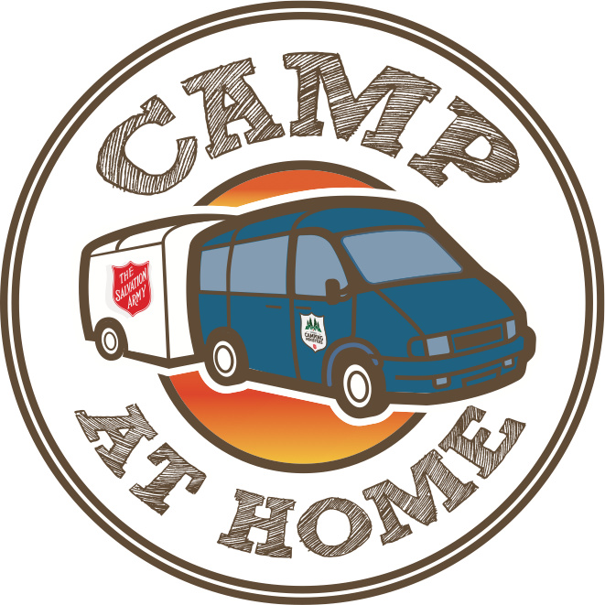

2022 Host Corps Information
One summer to Change eternity

PURPOSE:

The purpose of the CAH ministry is to provide a leadership team who will facilitate a week long Day Camp throughout the summer months in communities across the division.

GOAL:

The goal of the CAH ministry is to minister to both Corps and community children, ages 6-12, through a dynamic, high energy, Christ-centred, age appropriate Day Camp setting. The camp will run from approximately 8:30 am-4:30 pm, Monday-Friday. When possible, the team will be present for the Sunday to facilitate or support the Sunday worship service.

COORDINATION & OVERSIGHT:

CAH is coordinated by Ontario Camping Ministries. A Ministry Unit’s primary contact is Katie Fuentes. She can be contacted at katie.fuentes@salvationarmy.ca or by calling the camping office at 905 722 5751.

EXPECTATIONS OF ONTARIO CAMPING MINISTRIES:

A CAH Host Corps can expect the following from Ontario Camping Ministries:
- Provide a Mission Team (1 Coordinator & 4 Assistants) to plan and implement the program.
- Provide orientation and training sessions for the Mission Team.
- Provide transportation for the Mission Team.
- Provide promotional materials (i.e. posters, application forms, etc.) for use with campers and their families.
- Provide program materials for the Day Camp.
- Communication (i.e. telephone calls and emails) with Mission Team and Host Corps to monitor the program.
- Visit Ministry Units while the program is running when possible.
- Provide prayer support for the Mission Team and Host Corps on a daily basis

EXPECTATIONS OF THE CAH HOST CORPS:

- Accommodation & Meals: Provide billets, including breakfast and dinner, for the Mission Team. Please note:
  - The team’s arrival will depend upon whether they are offering to support a Sunday morning worship service at the host corps at the beginning or end of the week. This detail will be determined by the final list of host corps and the travel distance between them.
- A minimum of two billets will be required as the team will most likely be coed.
  - While at times the same gender may share the same billet or room, it is expected that each team member will have his or her own bed or sleeping area.
Team members, even of the same gender, are NOT to be expected to share beds or sleeping areas.
- Program Space: Provide a place where the program will operate (i.e. a large meeting room, lunch facilities, and a large outdoor space for recreational activities).
- Volunteers: Provide a minimum of 4 volunteers to assist the CAH Team with the registration and oversight of the campers. Volunteers must be a minimum of 18 years old and must also have completed the necessary background screening work.
- Meals: Provide snacks (morning and afternoon) and lunch for the CAH Team as well as campers. Please note that you may wish to ask campers to bring their own bagged lunches. If this is the case, the Host Corps will still be responsible to provide the CAH Team with lunches.
- Promotion: Promote the Camp at Home Program in your community and register campers.
- Follow up: Organize and run follow up programs for the campers. If OCM can be of any assistance with this, please access us as a resource.

COST:
The cost to a CAH Host Corps is a set fee of $2.000.00. This price will allow your Ministry Unit to register a maximum of 40 children to participate in the camp. Whether or not you choose to charge campers for attending the program is completely up to you. Please note that the fee of $2.000.00 in no way covers the costs of the Camp at Home Program. Divisional headquarters subsidizes the majority cost of the program.

IMPORTANT NOTE:
Being a CAH Host Corps is not a replacement for sending children and youth to our residential camping programs, run by Ontario Camping Ministries. It is meant to introduce or extend this unique experience!

